Role of Monetary Policy in the Japanese Housing Bubble of the 1980’s

Adam Chu

Dale Jorgenson

Wentao Xiong

December 9, 2014

Ec 980: Rise of Asia and the World Economy

**Introduction**

In the post World War II period, the country of Japan saw much economic success across all sectors. In the 1960’s especially, in what was called the “Economic Miracle of Japan,” manufacturing and production grew by multiples. An economist or analyst at the time would have never expected the series of events and realities that happened to Japan’s economy in the late 20th century. From December 26, 1989, the Nikkei 225 stock index peaked at 37,189 before it began its fourteen-year journey to a trough of 7,603.76 in April 2003, a drop of 30,000 points and a loss of 79.6%. The 1990’s and 2000’s have been colloquially referred to as what are called the “Lost Decades” of Japan. Over the period of 1995 to 2007, GDP fell from $5.33 to $4.36 trillion nominally, real wages fell by about 5%, and the country experienced stagnation at the consumer price index level. Economists and historians have theorized explanations for the reversal in progress from the “economic miracle” of the 1960’s to the stagnation of the early 21st century. Some point to fiscal policy, some to monetary policy, some to the Plaza Accord of 1985. As Paul Krugman, professor of economics and international affairs at Princeton University, writes: “the biggest lesson from Asia’s troubles isn’t about economics; it’s about governments. When Asian economies delivered nothing but good news, it was possible to convince yourself that the alleged planners of those economies knew what they were doing. Now the truth is revealed: They don’t have a clue. Even during the glory days, a visit to one of those planning agencies – say, Japan’s all-powerful Ministry of Finance – was enough to inspire a few doubts. I visited the Ministry of Finance in 1985 and saw what looked like the Pentagon’s War Room than like the Department of Motor Vehicles: dusty hallways, broken furniture, guys padding around in their socks, centerfolds taped to the dirty glass partitions. But maybe, I thought, appearances were deceiving. Then things started to go wrong, and the Ministry of Finance proved itself as hapless in action as it was in appearance. It’s easy to look competent in a prosperous economy (ask Bill Clinton), but the true test is whether you can cope with adversity. So much for the legendary managers of Japan Inc.” Krugman’s reflections from his firsthand personal experience of visiting Japan and seeing the environment shed light on the possibility that economics was not at play here in the unfortunate turn of events in Japan’s economy. Perhaps the government’s policies and posture were, perhaps it was a matter of exogenous factors.

In one popular theory involving the role of the Plaza Accord in leading to the Lost Decades, monetary policy is scrutinized as a potential culprit. In September 1985, delegates from G5 countries said the U.S. dollar was overvalued and agreed on a plan. In the plan, Japan and Germany, because they had main current account surpluses, would raise domestic demand and appreciate their currencies. All this contributed to an extraordinary appreciation of the yen of 46% against the United States dollar and by 1986, it had appreciated 30% in real terms. Next, Japan’s export and GDP growth slowed in the first half of 1986. When the Japanese government officials saw that the economy was stagnating and that the exchange rate was appreciating wildly, they decided to try a significant macroeconomic stimulus in the form of reducing the discount rate by 3 percentage points, bit by bit every year, until 1989. Japan’s output recovered and soon was on the rise, along with credit growth and asset prices, especially the capital markets and urban land prices. All this built up until the stock price bubble burst in January 1990. In the big question of whether the sequence was inevitable – did the appreciation force Japan to choose monetary easing to recover growth, which then caused a bubble, which then caused the Lost Decades when the bubble burst? – is customarily handled by looking at each segment and answering the smaller questions of inevitability. In this paper, we focus on monetary policy’s role in causing the bubble. Various models and methodologies will be employed, presented in both the body of the paper and the appendix.

**Vector Autoregression with Seven Macroeconomic and Housing Variables**

First, we take a look at analysis using a vector autoregression, a multivariate model for analysis with time lags and time series data. With the tool we are able to look at a variety of questions – was the monetary easing too loose? Should it have been tighter? Was monetary policy a major force contributing to the appreciation of housing markets? Was monetary policy (discount rate of the Bank of Japan) out of line given other macroeconomic and housing variables, and/or was the housing price index out of line given other macroeconomic and housing variables?

Following the examples of VAR analysis from the United States Federal Reserve, we conducted a vector autoregresion with seven macroeconomic and housing variables. Data for the macroeconomic variables for Japan were taken mainly from the World Bank’s World Development Indicator’s database, using advanced search features. Data for Japanese housing prices were taken mainly from the Japanese Real Estate Institute and Thomson Reuters. They were synthesized in a publication by the Economist and were drawn from there for regression purposes. The seven variables under consideration were: GDP in terms of current US dollars, Consumption defined by final consumption expenditure in current US dollars, Trade as a percentage of GDP, inflation using the consumer prices index as an annual percentage, house prices index drawn from Japanese Real Estate Institute / Thomason Reuters / Economist, Unemployment as a total percentage of total labor force (national estimate), and real interest rate as a percentage. The variables represent and cover a core set of macro and housing-related variables. Other papers – Del Negro and Otrok (2007, Jarocinski and Smets (2008), and Dokko (2009) have considered similar datasets, but mainly for the US housing price bubble situation rather than Japan’s of the 1980’s. The sample period that we use to estimate is 1977:Q1 to 1986:Q1 because the easing started approximately around 1986. We do this to know if what happened from 1986 and on deviated greatly from the predictions of the VAR. The VAR tells us factoring in the rest of the variables, what the expected path for a future period based on a historical period is projected to be. In our model, the VAR contains two lags for each variable, which is the default for the STATA software.

There are many ways with which to move forward and evaluate the period of 1986 to 1992, the period in which the bubble took its course. One possible way would be to use a recursive identification strategy to identify and examine monetary policy shocks. This would hinge on inductive inference and consist of identifying each function of a given class of recursive functions taking from a finite set of its output values. However, because of the availability and nature of data as well as a dearth of computer program resources, we will turn to a more traditional conditional forecast seen in many other researchers’ studies for our VAR. Conditional forecasts of this nature have been seen in such papers as Waggoner and Zha (1999), Clarida and Coyle (1984), Doan, LItterman, and Sims (1984), and Dokko (1992). The major benefit of this as opposed to using the recursive identification strategy is that the conditional forecast does not require identification of structure, which allows us to focus on correlation effects.

Based on the results, various conclusions can be drawn. If for example, the realized paths follow a similar trajectory from the conditional forecast path, this would suggest that the variable under consideration was typical of historical links with the set of variables that enter the VAR. If the realized paths were very different from the conditional forecast path, this would suggest that the path of the variable under consideration was atypical of historical links with the set of variables that enter the VAR. First, we look at a conditional forecast for the discount rate of the Bank of Japan for the period after 1986:Q1 using the parameters estimated for 1977:Q1 to 1986:Q1 and all of the observable data through 1992. The following figure presents the realized path and the simulated confidence interval bands at the 95% confidence level. This helps to answer the question – was monetary policy too loose?



Figure 1

From the figure above, we can see that most of the green dots which represent our data points of the discount rate set by the Bank of Japan fall within the 95% confidence interval of the forecast regression line. This is especially true from 1986 to 1992, which is the period in question. This suggests that policy was not unusually loose in this period. We can argue that the path of the discount rate over 1986 – 1992 has been very consistent with the policy strategy over the preceding decade. Thus, macroeconomic policy setting by the government of Japan seems to be aligned with the macroeconomic environment.

The next step examines house price growth. We use the macroeconomic variables as independent factors of the model to estimate a forecast of the house price trajectory. The relationship between confidence interval bands for housing variable and the realized path for the housing variable tells us whether the path of the housing variable is consistent with past relationships to macroeconomic variables, including monetary policy, i.e. the setting of the discount rate.



Figure 2

In the figure, the green dots represent annual data points of the housing market developments from the period of 1977 through 1992, though we are primarily concerned with the period of 1986 to 1992. It is evident that the path of the housing market developments goes far outside the 95% confidence interval grey band based on observed macroeconomic variables, including the Bank of Japan’s discount rate and the VAR’s other estimated parameters. The results suggest that accommodative monetary policy was supportive of macroeconomic activity and the housing market. Both simulations, taken together suggest that macroeconomic conditions did not drive the housing market developments in the period – at least not based on a regression taken on the historical paths constructed into the vector autoregression.

**Model Using Taylor Rule**

Although our vector autoregression of Japanese monetary policy over the period of 1977 to 1992 was the first apparently visible one of the current literature, the likes of other models such as one driven by Taylor Rule calculations have been pursued by other researchers and economists before. For this, we turn to a paper by Toshiki Jinushi, Yoshihiro Yuroki, and Ryuzo Miyao entitled “Monetary Policy in Japan Since the Late 1980s: Delayed Policy Actions and Some Explanations.” The main findings were that monetary policy was delayed, during 1987-1988. However, the implied rate from the model followed closely to the actual realized call rate by reasonable standard deviation bands. This suggests that the discount rates set by the Bank of Japan were not out of line with rates calculated by solid economics-grounded rules.

Just as we did in our vector autoregression, the Bank of Japan’s reaction function for the “pre-bubble” period of 1975-1985 is estimated. Analysis from policy experts shows that monetary policy during this time contributed to prosperity of the country with lower inflation. If most of the factors of the country stay the same, such as its industrial structure, then we can use this policy setting lag to predict a good policy for the bubble and post-bubble periods. A couple selected figures from the paper are presented next:

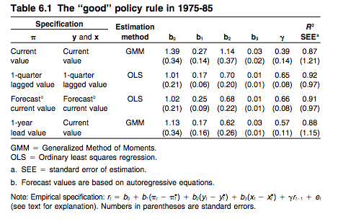

Figure 3

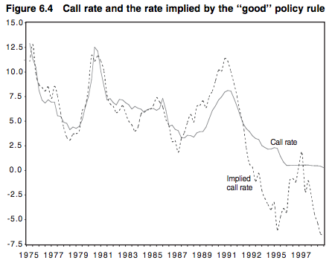

Figure 4

Using the approach from Taylor’s paper in 1998, an attempt was made to find deviations of actual monetary policy from the “good” policy rule. For the delay in policy restraint from 1987-1988, there were several explanations given. Some would consider this a “mistake,” but taking into account international foreign factors presented later in this paper and the next, it is hard to criticize the Bank of Japan outright. Going along with the Plaza Accord of 1985, the Bank of Japan was pushed to maintain a low interest rate. The United States stock market crash in October 1987 and market instability deterred Japan from tightening its monetary policy in late 1987. In 1988, the Bank of Japan had to wait until the sales tax was successfully introduced in April 1989 to implement restraint due to domestic political requirements.

**Japanese Monetary Policy Narrative**

Since World War II, Japanese caretakers have led various monetary regimes. Japanese monetary policy can be separated into two main phases, divided by the year 1987. In the first phase, inflation of the 1970s and price stability by the mid-1980s are characteristic. In the second phase, there was a bubble followed by post-bubble monetary policy. Figure 1 in the appendix shows money and nominal output growth for Japan from 1970 to 1998. Quarterly observations of four-quarter percentage changes of money (M2+CDs) and nominal output (GDP) are used. In Figure 2, real and nominal output growth for Japan for the years 1970 to 1998 are displayed. Quarterly observations of four-quarter percentage changes of real and nominal output (GDP) are used. In Figure 3, inflation in Japan is shown for the years 1970 to 1998 using quarterly observations of four-quarter percentage changes in prices (GDP price deflator) and heavy tick marks indicating fourth quarter of year. Next, we will analyze the implications of these three figures across the relevant time period for this paper (1970’s to 1992).

Before 1973, Japan kept the foreign exchange value of the yet to the dollar at the same rate. This was while the agreements made at Bretton Woods of 1944 were still in effect and before they unraveled in 1973. Since the exchange rate was fixed and the Japanese could not control U.S. prices, the Japanese government had to adjust its price level to get a balanced payments equilibrium. To get a balanced external accounts, Japanese had to match its baseline inflation with that of the United States. It was also inevitable that the Japanese price level would rise because their goods were becoming more coveted and sought after by the rest of the world. In order for trade to work out properly between Japan and the United States, Japan would have to maintain a higher inflation the United States during this time period. Because of the pegged exchanged rate, the Bank of Japan targeted its discount rate to pacify the current account balance rather than other matters within the domestic economy and country. The Bank of Japan figured out it could change current account balance by changing the discount rate three quarters in advance. When there were surpluses, the Bank of Japan lowered its discount rate, which caused money growth and increased inflation. When there were deficits, the Bank of Japan raised the discount rate and money growth and inflation slowed. The pegged exchange rate regime (360 yen to the dollar) was a positive one for the Japanese economy. Under Bretton Woods, from 1960 to 1990, the Japanese real GDP grew at 10.4% annually. During this time, Japan grew tremendously in the industries of automobiles, mass-produced goods, and other sectors. When Japanese exports became more sought after, Japanese prices were bound to rise relative to prices in the United States. As mentioned earlier, this would require the Japanese inflation rate to be higher than the United State’s, and during this decade, the Japanese’s was 3 points higher than the United State’s (using the GDP deflator).

A comparison of inflation during the 1960’s reveals the root problem of over and under appreciation of currencies in the United States and Japan. From 1960 to 1964, inflation in the United States rose annually by 1.4 percent, and from 1965 to 1970, inflation rose annually by 4.1 percent. Compare this to the situation in Japan where from 1960 to 1965, inflation rose annually by 5.8 percent, and from 1966 to 1969, inflation rose annually by 5.7 percent, which was much higher than the United State’s rate of 4.1 percent. This was due to Japan having more favorable trade terms. All this led to the yen being seriously undervalued by 1971 and the dollar being overvalued. In 1971, the United States trade balance turned negative for the first time in the twentieth century. This negative trade balance stemming from overvaluation of the dollar caused President Nixon to take action and force a chance in United States policy in summer of 1971. On August 15, Nixon announced his plan to lead a devaluation of the dollar. Before, the Fed had lowered short-term interest rates in response to United States recession. Nixon enacted a 10% surcharge on imports into the United States in an attempt to restore the trade balance. He also closed the gold window to foreign central banks. The 10% surcharge was a huge statement to foreign countries to get them to listen to the United States and revalue their currencies relative to the dollar. Starting during this time, the Bank of Japan purchased dollars to try to maintain the parity of 360 yen to the dollar. The Japanese created money starting in 1971Q3, which led to an increase in nominal GDP in 1972. Money creation continued until early 1973. With this back and forth threatening and bargaining, Japan and the other countries of Bretton Woods agreed to a devaluation of the dollar in December 1971. Japan’s agreement was that it would reevaluate the yen to the dollar of 16.9%, with a margin of fluctuation of 2.25%. The devaluation did not work, and the yen had risen to new highs by summer 1972. The Bank of Japan, because investors knew that foreign currencies would rise in relation to the dollar and they flooded the Bank of Japan with dollars for conversion, picked up buying dollars and expanding its money supply. Even after the United States and Japan made its agreement and made initial changes, in February 1973, inflation increased in the United States and the dollar weakened once again. This time, the Bank of Japan let the yen float rather than support it on a large scale by buying dollars. The Bretton Woods System collapsed in March 1973. The biggest lesson from Bretton Woods was that countries had to learn how to control the rate at which their central banks created money. This required allowing currencies to float against the dollar, and only then, could countries like Japan control their inflation rates.

For a decade, the Bank of Japan concentrated on reviving and keeping price stability. The consensus is that the Bank of Japan viewed steady money growth as important to establish a reputation for its policy of keeping inflation low, which it wanted to do given what happened in the 1960’s. The Bank of Japan used money in the form of M2 and CDs as a target. Various scholars such as Suzuki stated that the Bank of Japan considered one to two years as the time period for which monetary control was planned. Given this shortsightedness, policies may not have been perfect. Before 1974, it is said that monetary policy by the Bank of Japan only responded to the current account. A proposed improvement could have been that the Bank of Japan should have looked at short-term stability of money growth in setting the discount rate. From 1973 to 1986, the Bank of Japan went after nominal expenditure targeting to change short-term interest rates. In a manner to the previous “look at current accounts activity,” the Bank of Japan set the interest rate instrument in response to economic activity. Japan achieved moderate money growth and curbed inflation with this strategy. The long-run moderation in money growth caused money growth to be a constraint. When the Bank of Japan adopted the floating exchange rate scheme instead of pegged exchange rates, people began to view inflation as a monetary rather than a nonmonetary phenomenon. Countries increasingly began to assign control of inflation to their central banks. In the last half of the 1980’s, the Bank of Japan went away from its previous goals of stabilizing nominal expenditure and money growth. Again, it went back to its goal of stabilizing the exchange rate, even under a floating exchange rate scheme. The Bank of Japan wanted to prevent the interest rate and appreciation of the yen to increase, especially in light of the recent Louvre Accord of February 1987. Starting in 1986, the Bank of Japan moved partly toward the fixed exchange rate regime of the past using a dirty float. The Bank of Japan lowered short-term interest rates in response to a positive current account balance and a yen that was appreciating. In the terms that we use to describe monetary policy, lowering interest rates fell under the category of expansionary monetary policy.

**The Expansionary Era**

An expansionary policy had merits on different fronts. Stimulating domestic demand would help Japanese exporters out by cushioning the adverse effect of an appreciating yen on their exports. This would have been one domestic benefit of expansionary monetary policy. Stimulating domestic demand in Japan was also a wish of the United States. The United States government wanted Japan to reduce its payments surplus through increased imports. Just as in the late 1960’s and early 1970’s, when the United States threated Japan with retaliatory trade measures, by 1986 a wave of protectionism was enveloping the United States. Starting in 1985, the dollar began to depreciate against the yen again. Despite the Plaza Accord of 1985, the yen appreciated from about 260 yen to the dollar in early 1985 to 125 in early 1988. The Louvre Accord of February 1987 asked Japan to reduce its balance of payments surplus by expanding aggregate demand. The Bank of Japan pushed the three-month Gensaki rate from 7 percent in 1985Q4 to 3.75% in 1987Q3. As an aside, the gen-saki is a secondary market in Japan, known as a repo market similar to repurchase agreements. It is a medium for government bonds, specific to the Japanese market, to be reissued and resold at the new rate. Both corporations and financial institutions may buy gen-saki. Starting in 1987Q1, Japan’s money growth began to materialize. Money growth rose at 8.1% annual rate from 1982Q1 through 1986Q4 to 11.3% annual rate from 1987Q1 through 1990Q2. Real GDP growth began to rise in 1987Q3 because the Japanese had expected price stability. Real GDP rise at a rate of 3.3 percent annually from 1980Q1 through 1987Q2 and at 5.7 percent from 1987Q3 through 1990Q2. Also, in 1990Q2, inflation began to rise from 1% average annualized rate from 1985Q1 through 1989Q1 to 2.8% average annualized rate from 1989Q2 through 1991Q4. In the late 1980’s, during the bubble, the Bank of Japan decided that inflation targeting was inappropriate. It tried to vary its policy instrument, i.e. the discount rate, in response to asset prices rather than the prices of goods and services.

Despite the recessionary effects from the rapid appreciation of the yen and the decline of domestic production and capital investment (“yen-appreciation recession”), the yen hike in some ways brightened the outlook for the Japanese economy. The low price of imported oil during the period of 1986-1987 and strong yen prodded on consumer expenditures, such as housing investment and individual consumption, as well as the nonmanufacturing sector’s capital investment. Both the lowering of oil prices and the prices of imports moved Japan in a stably good direction. All in all, this 1986 “yen-appreciation recession” was benign until time progressed beyond 1986.

**Analysis of the Reduction in Discount Rate, 1986 and Onwards**

The discount rate was lowered by the Bank of Japan five times between January 1986 and February 1987. It was lowered from 5 to 2.5 percent in increments of half a percentage point. The goals of these reductions were to stabilize exchange rates and correct the trade imbalance by stimulating domestic demand, which both Japan and the United States wanted. These were normative goals that were not entirely country driven, so there is a big question of whether it was done entirely in the Bank of Japan’s and Japan’s interests. Nevertheless, the rationales issued by the Bank of Japan for each policy change from 1986 to 1987 are given as follows as quoted statements by the chairman of the policy board. On January 29, 1986, an ease of the discount rate from 5 – 4.5 percent targeted “redress the trade imbalance by stimulating domestic demand” and “closely watch the movement of exchange rates.” On March 7, 1986, an ease of policy from 4.5-4 percent targeted “redress of the trade imbalance by stimulating domestic demand” and “avoid drastic exchange fluctuations.” On April 19, 1986, an ease of 4.0-3.5 percent in the discount rate targeted “take more steps to correct the trade imbalance by stimulating domestic demand in coordination with the government’s package of economic policies” and “contribute to stabilizing the yen exchange rate.” On October 31, 1986, an ease of 3.5-3.0 percent in the discount rate targeted “since the government has prepared a supplementary budget for this fiscal year for the package of economic policies, the Bank of Japan … eagerly expects stable exchange rates to lead to continuous economic growth.” And finally, on February 20, 1987, an ease of 3.5 – 3.0 percent in the discount rate targeted “lately, Japan and the United States reconfirmed their cooperation in solving problems of the foreign exchange market, and we expect that the leading countries will closely coordinate efforts to stabilize exchange rates” and ‘Contribute to stabilizing exchange rates and encourage stead expansion of domestic demand.” The quotes imply that the 3rd and 5th reductions of the discount rate were driven by political pressure of international policy coordination. In March 1986, according to the Nikkei newspaper article of April 2, 1986, the United States Federal Reserve demanded the third reduction from the Bank of Japan. This led the Japanese government to prepare a package of economic policies of expansionary nature to stimulate domestic demand on April 8. A meeting between Takeshita and Baker concluded that both the United States and Japan were in a favorable position to coordinate reduction of the discount rate, that it would have favorable effects on both countries. During this agreement, the Bank of Japan Governor Sumita was aware of the imminent bubble, saying he was closely watching the speculative transactions of land and the rise of stock prices. Though the Takeshita and Baker agreement “concluded mutually” that it would be mutually beneficial to continue monetary easing, the Japanese officials clearly had misgivings and prudently monitored activities, based on their issued statements. For the fourth and fifth reductions in discount rate, the Bank of Japan appeared to initially resist the reductions. Governor Sumita stated that “we would not need further monetary loosening” as recorded in the Nikkei newspaper on October 5, 1986. “We will continue to watch carefully the movements of economic situations, including the money supply. We hope that financial institutions will keep a deliberate lending attitude.” In light of these statements, it is obvious the political pressure placed on domestic monetary policy in Japan. The G-7 finance ministers voted that the country with the trade surplus (Japan) should achieve the faster economic growth on September 27, 1986. This forced Japanese Finance Minister Miyazawa to pledge publicly to stimulate domestic demand. Furthermore, on October 1, 1986, United States Secretary of the Treasury Baker asked Japan and Germany to additionally lower their discount rates.

From the many issued statements by the Bank of Japan during this period, it is clear the BOJ had sniffed the dangers of the cotemporary financial and economic conditions. It is also clear that international pressure placed a great weight on Japan to act in a way that was beneficial enough for other countries of the world, including the United States. We list a selection of five quotes from the Bank of Japan to give an idea of their level of understanding of the situation. “Excessive monetary expansion, however, does not contribute to real economic growth, but will quite possibly support speculative transactions of existing assets” (April 1987). “The money supply is considerably high compared to real economic activities...the discount rate is at the lowest level up to today” (January 1987). “The deflationary shock can be widespread once asset prices start falling, since the hike in those prices has been aided by speculative transactions … excessive monetary expansion will have an adverse effect on sound and stable economic growth in the long run, although it is appropriate to maintain today’s easy-money policy for a while” (May 1987). “Monetary policy stance supporting speculative transactions of assets can damage long-run price stability” (January 1987). “It is appropriate to keep today’s stance of easy money for a while to attain continuous expansion of domestic demand and stable exchange rates” (April 1987). The Louvre Agreement at the G-6 conference stated that the Bank of Japan would reduce the discount rate by .5% in February 20, 1987. The G-7 conference in April 1987 reconfirmed the Louvre Agreement. The Japanese government decided on a package of economic policies that included the reduction of the deposit rate to the Fund Management Bureau at the Ministry of Finance. The many quotes above support that the Bank of Japan had a levelheaded and directed stance on policy against further monetary expansion. However, time after time, requests from foreign powers and commitments between foreign and domestic powers laid the pathway for monetary policy decisions of the Bank of Japan. Each time, the Bank of Japan changed its policy stance and agreed to further monetary expansion. The third to fifth out of the total five reductions of the Japanese discount rate were fueled largely by political pressure from foreign and domestic forces.

In the spring of 1986, the Bank of Japan issued a statement, “the cumulative decline of the velocity (nominal aggregate demand / M2 + CD) is larger than that of the last easy-money period … we cannot deny the speculative aspects of land transactions based on the quantitative ease of money. Backed up by the increasing funds’ inflow to the stock market, those prices are going higher, regardless of business prospects. Money supply is considerably high compared with real economic activities. By 1987, it was clear the Bank of Japan saw the harm of excessive monetary loosening. The Bank of Japan had an understanding that the burst of a bubble could be harmful for the financial system and real growth. The strategy the Bank of Japan undertook was similar to a commodity standard monetary regime. The central bank tried to influence the nominal price of a broad collection of assets – the country’s capital stock in equities and land, instead of just trying to fix the nominal price of an asset like gold or oil. Japan’s monetary policy became highly contractionary in the early 1990’s. Goods and prices were deflated because a large part of the rise in Japan’s asset prices was formulated from real factors. The rise in asset prices since 1987 had derived from real factors. In the late 1980’s, Tokyo had become an Asian center for growth in the information technology and service sectors, and the price of land rose along with that. Furthermore, Tokyo became more attractive as an international financial center with the deregulation of Japanese financial markets in the 1980’s. Starting in May 1989, the Bank of Japan began pushing interest rates up sharply. From 1989Q2 to 1990Q4 and 1991Q1, the Gensaki rate went from 4.3% to 7.6%. Money growth began to fall in 1990Q3, and real GDP didn’t grow very much from 1992Q2 through 1995Q1. Land prices began crashing in 1991 and are still falling in the present day.

**Conclusion**

Our narrative supported by two models rationalize much of the monetary policy decisions of the Bank of Japan in the period leading up to and during the well-known housing bubble of the late 1980’s in Japan. Both the vector autoregression (performed originally in this paper) and Taylor Rule model (reflected on from a previous study) suggest that Japan’s monetary policy did not drive housing developments. Furthermore, what some see as excessive easing and expansionary policy can be partly justified by the immense political pressure of international policy coordination that the Japanese government was under during this time.

If monetary policy was not to blame for the balloon of the bubble and following Lost Decades, what was to blame? Various scholars suggest: bank behavior, land laws, the tax system. Over-investment, measured by fixed investment as a percentage of GDP, increased exponentially to 40% toward the end of the bull phase. This was double the average ratio in other peer countries. Excessively easy credit and bank lending encouraged export activity, rising equity prices, infrastructure creation, and housing spending. Significant was the rise in non-performing bank loans and the zombie banks that encountered bad debts for an extended period of time. Next, Japan has a complicated tax system consisting of a very high inheritance tax. Capital gains are not taxed until the time of sales and interest payments are taken out from taxable income for entities investing in assets. When the land price skyrockets much faster than the tax rate, Japanese entities may consider lands as assets rather than blocks for production. Speculation then occurs. Regarding the land lease law, in the event of a dispute between tenant and lessee, the court may call for a hearing to make sure that the rent is reasonable and fair. Due to the rules of the game, many landlords decided against renting out their land at a discount and instead to keep the land deserted in order to get a huge capital gain in the event of an exponential rise in land price. Perhaps through a look at Japanese monetary policy effects on the housing landscape as well as an investigation into national policies in relation to other countries’ bubbles, we can begin to understand a bit more the intricacies of monetary policy, macroeconomic patterns, and what drives the development and fall apart of bubbles.

**References**

Dokko, Jane et. al. “Monetary Policy and the Housing Bubble.” *Finance and Economics*

*Discussion Series Divisions of Research & Statistics and Monetary Affairs*.

2009. Electronic.

Hetzel, Robert L. “Japanese Monetary Policy: A Quantity Theory Perspective.” *Federal Reserve*

*Bank of Richmond*. Accessed 4 December 2014.

[https://www.richmondfed.org/publications/research/economic_quarterly/1999/winter/pdf/ hetzel1.pdf](https://www.richmondfed.org/publications/research/economic_quarterly/1999/winter/pdf/%09hetzel1.pdf)

International Monetary Fund. “World Economic Outlook.” *World Economic and Financial*

*Surveys*. October 2009. Electronic.

Jinushi, Toshiki et. al. “Monetary Policy in Japan Since the Late 1980s: Delayed Policy Actions

And Some Explanations.” *Peterson Institute*. Accessed 2 December 2014.

Krugman, Paul. “What Ever Happened to the Asian Miracle.” *Massachusetts Institute of*

*Technology*. Accessed 9 December 2014. <http://web.mit.edu/krugman/www/perspire.htm>.

<http://www.petersoninstitute.org/publications/chapters_preview/319/6iie289X.pdf>.

Takatoshi Ito and Frederic S. Mishkin. “Two Decades of Japanese Monetary Policy and the

Deflation Problem.” *Nationa Bureau of Economic Research*. Accessed 7 December

2014. http://www.nber.org/chapters/c0092.pdf.

**Appendix**

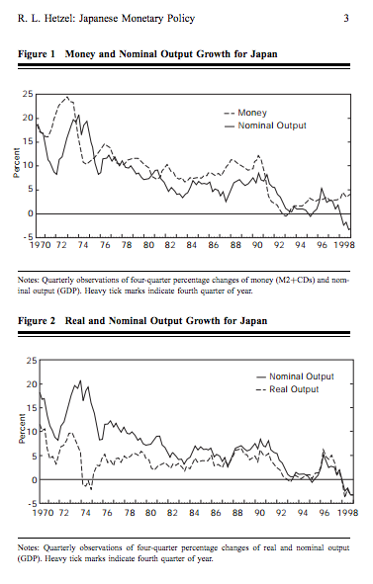

Figure 5

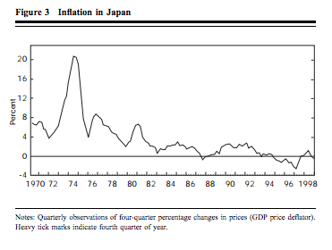

Figure 6

An Excerpt from Reed’s “Vector Autoregression and Vector Error-Correction Models”

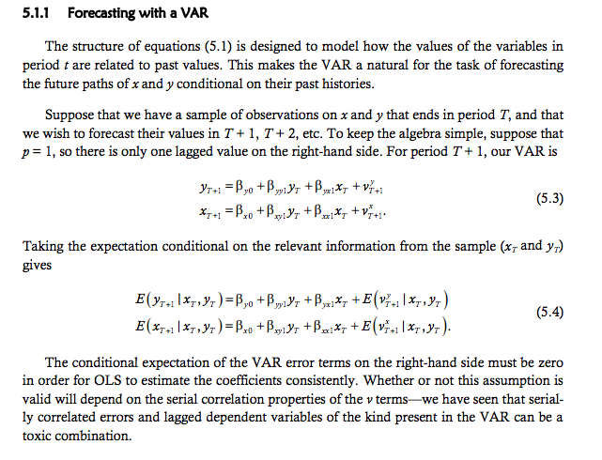

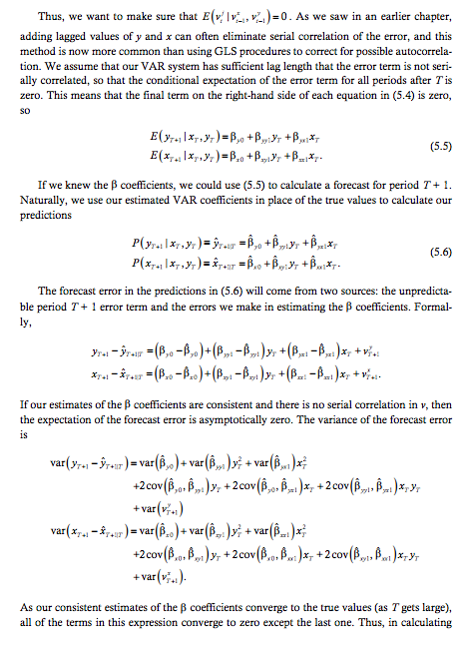



VAR Regression above for Discount Rate



VAR Regression above for House Prices

